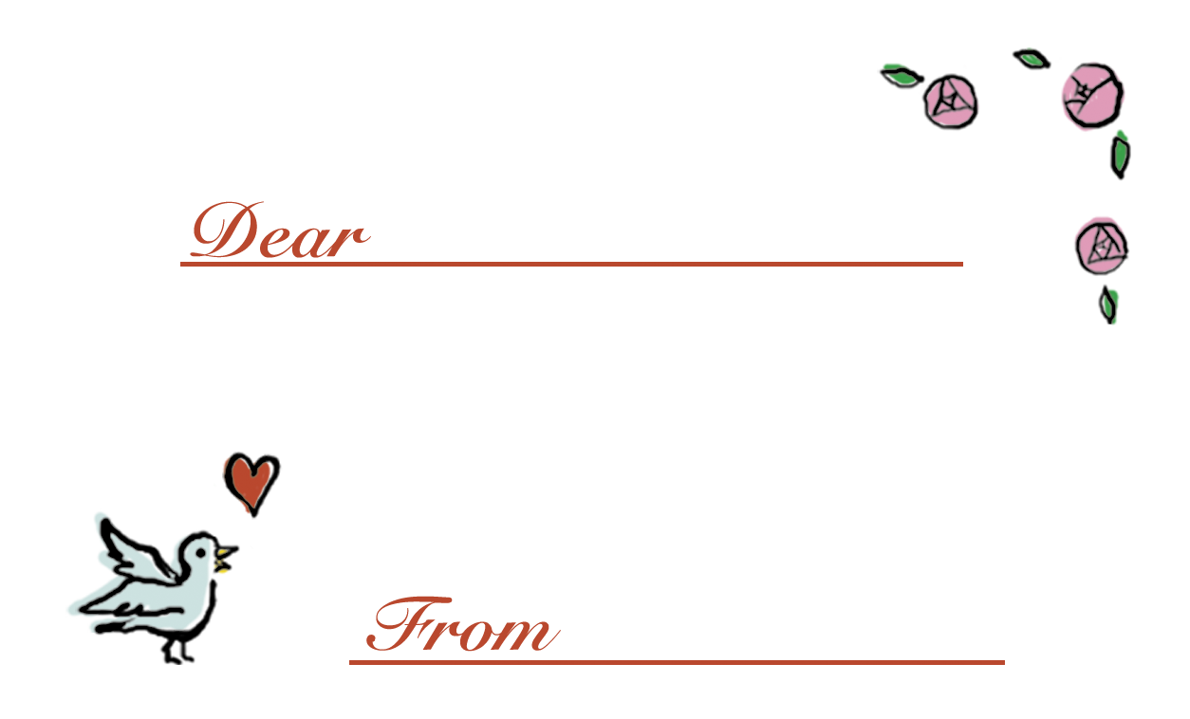
Sayaka
Kana
Thank you for your friendship.
Dream high and try to reach!

